ME DOE numbers from our October 1 counts (point in time) of McKinney-Vento students statewide has increased 50% from one year to the next.

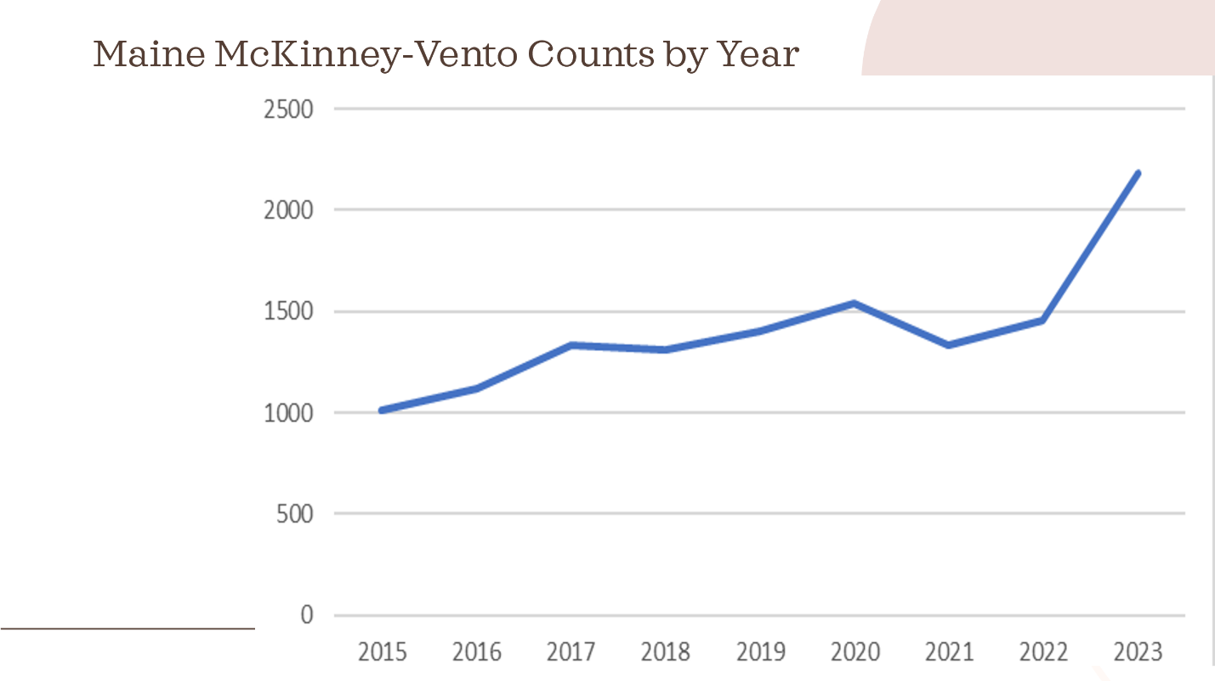

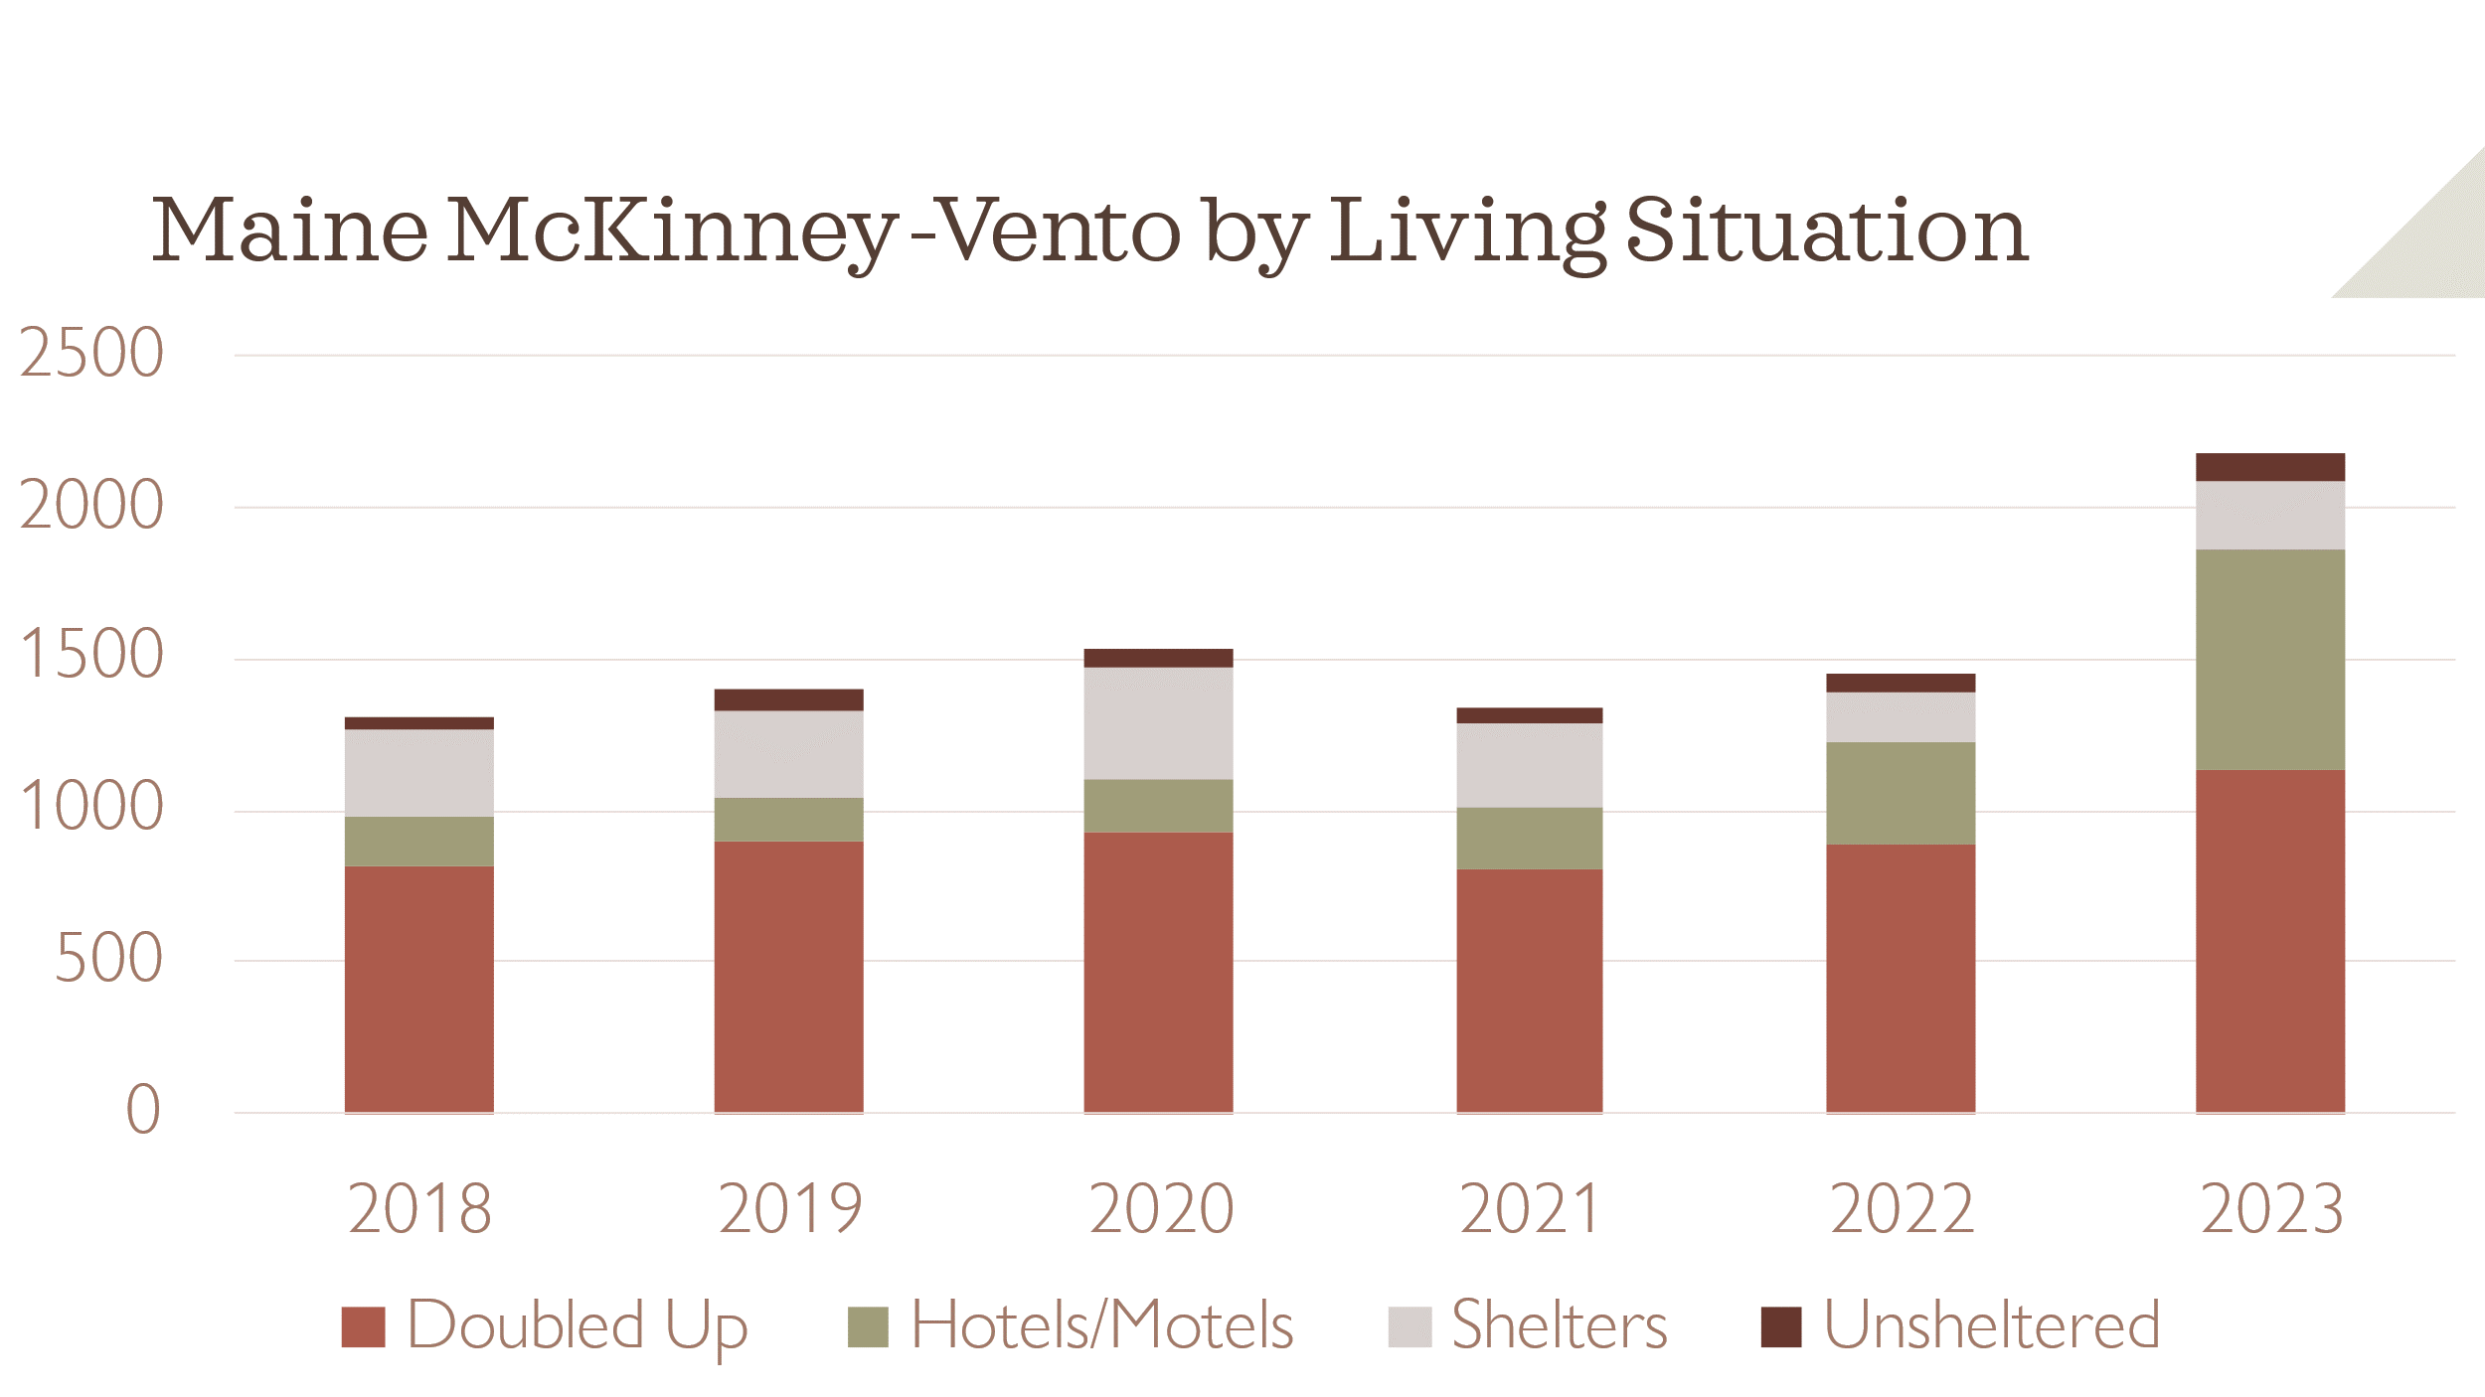

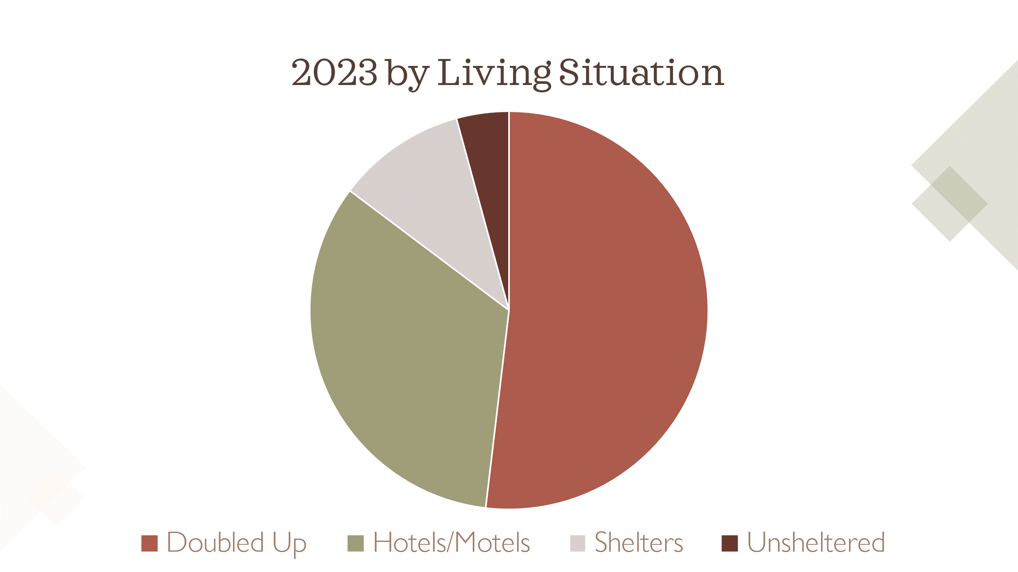

|  |  |  |  |  |  |  |  |  |  |  |  |  |  |
| --- | --- | --- | --- | --- | --- | --- | --- | --- | --- | --- | --- | --- | --- |
| **Annual Count of Publicly Funded Homeless Students** | | | | | | | | | | | | | |
|  | **School Year** | | | | | | | | | | | **%Δ over 10 years** | |
| **Student Group** | **2014** | **2015** | **2016** | **2017** | **2018** | **2019** | **2020** | **2021** | **2022** | **2023** |  |  |  |
| **Not Homeless** | 181947 | 181816 | 180885 | 179582 | 179366 | 179412 | 178799 | 171139 | 171780 | 171721 | **-5.62%** | |
| **Homeless** | 2330 | 1015 | 1122 | 1336 | 1311 | 1405 | 1537 | 1335 | 1457 | 2186 | **-6.18%** | |
| **Doubled Up** |  |  |  |  | 812 | 895 | 929 | 808 | 888 | 1134 |  | |
| **Hotels/Motels** |  |  |  |  | 167 | 146 | 177 | 206 | 337 | 730 |  | |
| **Shelters** |  |  |  |  | 285 | 284 | 370 | 270 | 165 | 229 |  | |
| **Unsheltered** |  |  |  |  | 47 | 80 | 61 | 51 | 67 | 93 |  | |
| **Total Students** | **184277** | **182831** | **182007** | **180918** | **180677** | **180817** | **180336** | **172474** | **173237** | **173907** |  | |
| **State Average** | **1.26%** | **0.56%** | **0.62%** | **0.74%** | **0.73%** | **0.78%** | **0.85%** | **0.77%** | **0.84%** | **1.26%** |  | |