SHC Membership:

Stephanie Primm, Chair

MaineHousing

Maine Department of Health & Human Services:

- Office of Behavioral Health

- Office of Child and Family Services (OCFS)

Maine Department of Corrections (DOC)

Maine Bureau of Veterans Services

Region I Reps:

- Cheryl Harkins

- Donna Yellen

- Virginia Dill

Region II Reps:

- Cullen Ryan

- Donna Kelley

- Emily Flinkstrom

Region III Reps:

- Josh D’Alessio

- David McCluskey

- Tracey Hair

Statewide Homeless Council
c/o MaineHousing
26 Edison Drive
Augusta, ME 04333

July 2, 2021

To: Statewide Homeless Council
From: Stephanie Primm, Chair
Lauren Bustard, Senior Director of Programs, MaineHousing
RE: Final CSH Report attached---Considerations prior to reviewing

Dear Colleagues,

Attached is the final report generated by the team at Corporation for Supportive Housing (CSH).

Thank you to all of you who contributed to this year long process with your time, knowledge and wisdom.

Some context we’d like you to consider in reviewing the report includes the following:
- The final recommendations and methodologies/interventions contained herein are those of CSH and are grounded in their national experience as well as their time looking at our current system and data available.
- CSH was retained as a consultant to provide us with their opinion about what mix of interventions can help Maine strengthen the homeless response system and move the needle for systemic change and improvement.
- CSH philosophy is grounded in supportive housing and creation of affordable housing. Long term strategies in their experience work to reduce the need for shelter in some states they’ve worked with, but reduction in the need for shelter can only happen when all interventions are funded and running efficiently and effectively. Unlike what occurred with the Deinstitutionalization mandate, we need to ensure that individuals and families experiencing homelessness have a safe place to be while we work on building a system that will prevent and reduce homelessness in the longer term.
- Together we must view these foundational results with our own filters and recommend changes as Maine Statewide Homeless Council members and contributors. We must consider and evaluate budget allocations and methodologies, basis for data, shelter capacity and format and ‘front door’ considerations. Only after we’ve reviewed this together and finalized will it be ‘our collective plan’.
- An example of what is missing from this report is attention to shelter needs in geographic areas where there are no resources—and some interim considerations based on COVID/congregate considerations and current increasing need.
- The implementation of our plan will take years—and represents a ‘long term view’, but we will get there together and will consider short term needs as part of the long term step by step approach for Maine in order to do our best for those experiencing or at risk of homelessness.

We plan on dedicating the July 13 meeting to discussing CSH’s plan together and identifying what we collectively feel needs to be adjusted or changed or added. As you are able to, please be ready to bring your positive input about the plan, what works, what makes most sense to you—and what you may feel needs to be addressed more fully, what is missing for Maine to be successful in strengthening our homeless response system and ultimately creating positive systemic change for our most vulnerable and for generations to come.

Thank you all. Look forward to seeing everyone on July 13.
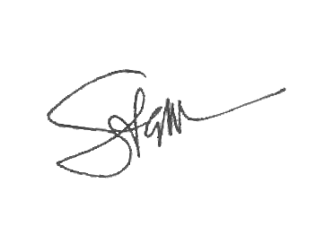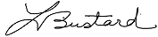
Steph Primm, Chair Lauren Bustard, MaineHousing

