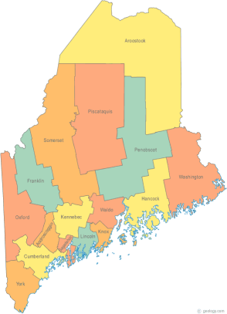 | Meeting of the Maine Continuum of Care  September 21, 2017 1:00 pm to 3:00 pm (ok, maybe 4:00)  Meeting at SIX locations via Tandberg Conferencing System.  - Turner Memorial Library, 39 2nd St., Presque Isle (call ahead to let them know)  - Farmington Public Library, 117 Academy Street, Farmington (call ahead)  - MaineHousing, 353 Water Street, Augusta  - Lewiston Public Library, 200 Lisbon Street, Lewiston  - Portland Public Library, 5 Monument Square, Portland  - Bangor Public Library, 145 Harlow St. Bangor  THE CALL-IN ONLY NUMBER FOR THIS MEETING IS 866-6433.  If you are at a Tandberg Location, use the system audio, not the call in #.  And please – only use the call in if you cannot make it to a Tandberg site.
---Agenda Items---
- Member Introductions |  | All
- Review & Approval of minutes |  | All | Need to Vote
- Big Thinking Topic – 2017 MCOC NOFA Submission  - Review of the Full MCOC NOFA Application  - Deadline is next Thursday, Sept 28, 2017  - Vote to finalize for Submission to HUD  - Scoring and Ranking Results  - Review of Monitoring Process/Results  - Review of Selection Process/Results  - Selection Committee Recommendations  - Vote to finalize for Submission to HUD |  | All | Need to Vote  Need to Vote
- MCOC Governance  - Addition of Youth Committee description  - Vote to approve as Final |  | All | Need to Vote
- HMIS Governance Ad Hoc Committee Update  - HMIS Policies and Procedures  - HMIS Governance & MOU  - HMIS Roles and Responsibilities |  | All | Votes ?  (if need to be finalized and attached to NOFA app)
- State and Federal Legislation |  | Cullen
- Statewide Homeless Council |  | Cullen
- Regional Homeless Council Updates |  | All
- Long Term Stayers Update |  | All
- CoC Board Update  - Consolidation Committee Update – Standing agenda item  - Coordinated Entry Update – Standing agenda item |  | All
- Committees, Committee Membership, and Committee Chairs |  | All
- Any Other Business |  | All
Next Meeting: September 21, 2017, 1pm to 3pm

Please read all materials prior to attending the meetings in order to be prepared to participate in the discussion.
Materials posted at www.mainehomelessplanning.org Contact stibbitts@mainehousing.org for more information.

