Policy/Advocacy Update – 7/7/2017

Federal Legislation Update:
FY17 Appropriations – No New Update – A final FY17 spending package has been enacted to fund the federal government through September. At more than $1.07 trillion, the final budget agreement upholds the bipartisan deal made in late 2015 to lift the spending caps required by Budget Control Act for defense and non-defense programs.

HUD FY17 Appropriations – No New Update – The FY17 spending bill funds most HUD programs at or above FY16 levels, but below the high-water marks provided in the draft versions. The only programs to see funding cuts compared to FY16 were the Public Housing Operating Fund ($4.4 billion in FY17 compared to $4.5 billion in FY16) and Section 811 Housing for People with Disabilities ($146 million in FY17 compared to $151 million in FY16). In some instances, the FY 17 appropriations, though higher than FY 16, are not enough to cover renewals.
- Tenant-Based Rental Assistance: The spending package provides $20.292 billion for tenant-based rental assistance, $18.355 billion of which is to renew previous contracts – it is estimated that this is enough to cover 97% of current contracts. The bill allocates $47 million for Veterans Affairs Supportive Housing (VASH) which includes an additional investment of roughly 5,000 vouchers, $7 million of which is to serve Native American veterans. The bill also provides $10 million to support new Family Unification Program (FUP) vouchers and $120 million for Section 811 mainstream vouchers.
- Project-Based Rental Assistance: The bill provides $10.816 billion to renew project-based rental assistance contracts for calendar year 2017, an increase of $186 million from the FY16 funding level.
- Homeless Assistance Grants: The bill increases funding for homeless assistance programs to $2.383 billion from $2.25 billion in FY16. The bill targets $43 million to address youth homelessness and waives the requirement that youth 24 years of age and under provide third-party documentation to receive housing and supportive services within the Continuums of Care. The bill extends the authorization for the U.S. Interagency Council on Homelessness (USICH), which is set to expire this year, by one additional year.
- HOME: The bill would level-fund the HOME Investments Partnerships program (HOME) at $950 million.
- CDBG: The bill would level-fund the Community Development Block Grant program at $3 billion.
- USICH: The bill provides a one-year extension for the United States Interagency Council on Homelessness (USICH).

House FY 2018 Appropriations – First steps – New: The House has yet to release a T-HUD bill for FY 18, however House Appropriators have been directed to draft allocations assuming a $511 billion topline for nondefense discretionary spending (vs. the White House’s budget requesting $462 billion). This is $4 billion below FY 17 allocations, though a better outlook than the President’s budget proposal which proposes cutting $7.7 billion from HUD alone. The likely course of action for FY 18 spending will be some form of Continuing Resolution before the FY 18 begins on 10/1, after which Congress will work to pass a complete spending package. FY 18 spending is subject to the full effect of the BCA caps.

President Trump’s proposed FY 18 budget (from CBPP & NLIHC) – No New Update: President Trump released his budget on 5/23. The $4.094 trillion FY 18 budget calls for cuts that hit Medicaid, food assistance and other anti-poverty programs. Over the next decade, the budget calls for slashing more than $800 billion from Medicaid, while cutting $192 billion from nutritional assistance, and $272 billion over all from welfare programs. The plan would cut by more than $72 billion the disability benefits. And, NDD programs, whose budgets are determined annually by Congress, would see funding cut by $57 billion, or 10.6%.
The President’s FY 18 budget includes a $7.7 billion—or 7%—cut to HUD programs compared to FY17. The proposed cuts could mean more than 250,000 people could lose their housing vouchers. It would also impose punitive measures that would jeopardize family stability.
The budget proposal provides the HUD secretary with the authority to: Increase a tenant’s rent contributions from the current standard of 30% of their income to 35%; increase the minimum monthly rent for tenants to $50, beginning with a tenant’s first annual or interim authorization; prohibit tenants from receiving utility reimbursements used to cover the cost of heat and water; and not provide rent adjustments for properties receiving housing assistance.

Specifically, the HUD budget:
- Eliminates: CDBG, HOME, Choice Neighborhoods, the National Housing Trust Fund, and funding for USICH.
- Public housing: Capital fund reduced from $1.942 billion in FY 17 to 628 million – a 68% cut. The operating fund would fall from $4.4 billion in FY 17 to $3.9 billion.
- Housing Choice Vouchers: Funded at $19.318 billion, a 5% cut compared to FY 17 funding. NLIHC (and other outlets) estimates this equates to more than 250,000 vouchers being lost.
- Project-Based Section 8: Funded at $10.351 billion, a cut of $465 million vs. FY 17 funding. This is not sufficient to cover existing contracts.
- Homeless Assistance Grants: Reduced from $2.383 billion in FY 17 to $2.25 billion.
- HUD 811: Cut by $25 million
- Family Unification Program and HUD-VASH: Funding zeroed out (except for $7 million for HUD-VASH targeting Native Americans).
- HOPWA: Funding reduced from $356 million in FY 17 to $330 million.
- USDA Rural Housing – Rental Housing: $60 million cut to Section 521 rural rental assistance; eliminates funding for the Multi-Family Preservation and Revitalization demonstration. RD: Elimination of the Section 504 Rural Housing Assistance Grants.
Other Agencies:
- The budget would also eliminate LIHEAP and Community Services Block Grants through DHHS.
- Cut Medicaid by nearly 25%, or $839 billion over a decade – on top of the $800 billion cut included in the House AHCA.
Effect of the President’s FY 18 HUD budget cuts on Maine (per CBPP analysis):
State | Vouchers Cut | Public Housing Funding Cut | CDBG Funding Cut | HOME Funding Cut
ME | -1,395 | -$5,989,305 | -$16,416,154 | -$4,237,285

National Housing Trust Fund – No New Update: The HTF is the only federal program designed to build and preserve housing affordable to people with the lowest incomes. We must ensure that the program is protected – not eliminated.

The Affordable Care Act (ACA): The House Republican health plan, “The American Health Care Act,” unveiled on 3/6 and then pulled from the House floor before a vote could take place, was revamped for reconsideration in Congress. It has passed the House and has been sent to the Senate for consideration. According to CBPP, the newly released Meadows-MacArthur amendment would eliminate key Affordable Care Act (ACA) protections for people with pre-existing conditions. The Meadows-MacArthur amendment would largely restore pre-ACA rules for people with pre-existing conditions. Just like before the ACA, insurers could discriminate based on medical history, eliminate coverage for key health services, and impose annual and lifetime limits on benefits.
The Senate unveiled its bill to repeal and replace the ACA, the Better Care Reconciliation Act (BCRA) on 6/22. The bill was set to be voted on before the July 4th recess, but was pulled. Senate Majority Leader McConnell is working on revisions to the bill to earn enough votes for passage, with a potential vote occurring in or around mid-July, before the August recess. What was released retains the most harmful structural features of the House bill, and according to the CBO would cause 22 million people to lose Medicaid coverage over the next 10 years.
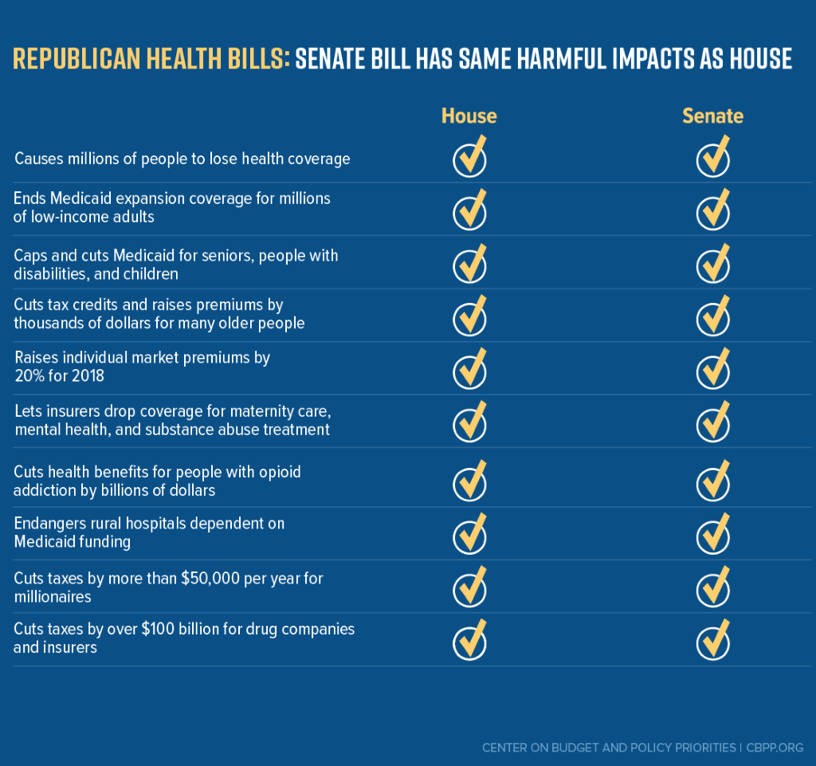
Now is the time to reach out to Senator Collins regarding preserving Medicaid/MaineCare funding and access to healthcare for Maine.

S. 743: A Bill to Strengthen the United Stated Interagency Council on Homelessness No New Update. Senators Collins and Reed introduced legislation on 3/28 to strengthen and eliminate the sunset for the U.S. Interagency Council on Homelessness (USICH). Referred to the Senate Committee on Banking, Housing, and Urban Affairs.
Senate Democrats Unveil Comprehensive Infrastructure Plan, Affordable Housing Included No New Update. Senate Democrats unveiled their infrastructure plan, a $1 trillion plan aiming to create over 15 million jobs, and addresses issues including broadband internet, downtown revitalization, water and sewer, schools, roads and bridges, and also includes investments for public and affordable housing.
H.R. 161: Services for Ending Long-Term Homelessness Act – No New Update. Sponsored by Representative Hastings (Florida). This bill would amend the Public Health Service Act to establish a grant program to provide supportive services in permanent supportive housing for chronically homeless individuals and families, and for other purposes. Referred to the House Energy and Commerce committee.
H.R. 948: The Common Sense Housing Investment Act of 2017. Sponsored by Rep. Keith Ellison. No New Update. To amend the Internal Revenue Code of 1986 to replace the mortgage interest deduction with a nonrefundable credit for indebtedness secured by a residence, to provide affordable housing to extremely low-income families, and for other purposes.
H.R. 2076: Ending Homelessness Act of 2017 – No New Update. Introduced on 4/6 by House Financial Services Committee Ranking Member Maxine Waters (D-CA).

State Legislation Update: New updates are underlined
-Governor LePage’s Biennial Budget – NEW – The a revised, amended version of the Biennial Budget was signed into law in the very early hours of 7/4. It appears that $2.5 million in each fiscal year of the biennium has been deallocated from Maine’s HOME fund, and instead allocated to the General Fund.
Bills of note:
- LD 136, An Act Regarding the Eviction Process, sponsored by Sen. Scott Cyrway (R-Kennebec), would expand the causes for a 7-day notice of termination of tenancy listed in 14 MRSA §6002 to include the following three additional reasons:
  - The tenant or the tenant's guest or invitee is the perpetrator of violence, a threat of violence or sexual assault against another tenant, a tenant's guest, the landlord or the landlord's employee or agent;
  - The person occupying the premises is not an authorized occupant of the premises; or
  - The tenant provided false information on the tenant's rental application.
Signed into public law.
- LD 1620, An Act To Reform Welfare for Increased Security and Employment, presented by Rep. Fredette (Governor’s bill). This bill makes a number of changes to the statutes relating to programs administered by the Department of Health and Human Services. Divided report out of Committee. Unfinished business in the House as of 6/27.

GA BILLS
The following GA bills are dead:
- LD 36, An Act To Create a 9-month Time Limit on General Assistance Benefits for Certain Persons, sponsored by Sen. Brakey.
- LD 10 "An Act To Build Greater Accountability into the General Assistance Program by Increasing the Penalty for Falsely Representing Information on an Application for General Assistance." Sponsored by Representative Picchiotti.
- LD 219 "An Act To Prioritize Use of Available Resources in General Assistance Programs." Sponsored by Senator Brakey.
- LD 220 "An Act To Align Time Limits in the Municipal General Assistance Program and Temporary Assistance for Needy Families Program." Sponsored by Senator Brakey.
The following GA bill was signed into public law:
- LD 221 "An Act To Amend the Laws Regarding the Municipality of Responsibility for General Assistance Applicants Released from a State Correctional Facility or County Jail Facility." Sponsored by Senator Gratwick.
The following GA bill was committed the HHS Committee and remains unfinished business:
- LD 1109 "An Act To Improve General Assistance Reimbursements." Sponsored by Senator Chipman.

TANF BILLS
The following TANF bills are dead:
- LD 33, An Act To Adjust the Lifetime Limit for the Receipt of TANF Benefits, sponsored by Sen. Eric Brakey.
- LD 477 An Act To Prevent Long-term Welfare Dependency, sponsored by Rep. Deborah Sanderson.
- LD 1017 An Act To Strengthen Work Participation in the Temporary Assistance for Needy Families Program, sponsored by Rep. Deborah Sanderson.
- LD 1052 An Act To Allow Drug Testing Prior to Providing Welfare Benefits, sponsored by Rep. Jeffery Hanley.
- LD 1075 An Act To Eliminate Drug Use among Welfare Recipients, sponsored by Rep. Karleton Ward.
- LD 1302 An Act To Increase Workforce Participation in the Temporary Assistance for Needy Families Program and Other Assistance Programs, sponsored by Rep. Colleen Madigan.
- LD 1408 An Act To Establish an Independent Citizens Oversight Committee on Maine's Welfare Programs, sponsored by Senator Nathan Libby.
The following TANF bill became law without the Governor’s signature:
- LD 336 An Act To Amend the Requirements of the Temporary Assistance for Needy Families Program sponsored by Rep. Dale Denno –Increases special housing allowance and removes some barriers for 2-parent families.
The following TANF bill was vetoed by the Governor:
- LD 481 An Act To Promote Workforce Participation, sponsored by Rep. Harold Stewart – Summary: This bill in effect helps to eliminate to “TANF-cliff” for people attempting to work so they don’t immediately lose benefits upon receiving earned income.

Other Bills:
On the Special Appropriations table, pending funding for enactment (with extremely limited funding remaining after the enactment of the Biennial Budget, bills on the Special Appropriations Table will likely be carried over):
- LD 970, An Act To End Homelessness by Expanding Housing Support Services, sponsored by Rep. Erik Jorgensen, would establish the Housing First Assistance Program at MaineHousing. Amended to reduce the funding provided for the Housing First Assistance Program from $675,000 to $300,000 per fiscal year.
The following bills are dead:
- LD 832, An Act To Carry Out the Will of the People of the State of Maine by Ensuring the Issuance of Bonds To Support the Independence of Maine's Seniors (EMERGENCY).
- LD 1560, An Act Regarding Veteran Homelessness, sponsored by Rep. Harold Stewart.

Other items of interest:
DHHS 1115 Waiver Application – Among the reforms the waiver application requests are changes for “able-bodied” adults: Work requirements, monthly premiums, eliminating presumptive eligibility for hospitals, co-pays, charges for missed appointments, “non-emergency” ER visits (where the person is not admitted) results in a copay, asset tests and limitations, eliminating retroactive eligibility. DHHS hosted two public hearings and had a 30-day public comment period, which ended on May 25, 2017.

Next steps in the MaineCare Section 1115 waiver process, per Maine Equal Justice Partners (MEJP):
- The state will summarize the comments and prepare responses to the comments, much like they do in rulemaking.
- MaineCare Services will submit their waiver request to CMS. The request will include a report indicating issues raised during the comment period and how the state considered those comments.
- After receiving the state’s waiver application, CMS has 15 days to determine completeness. If the application is complete, then a 30-day federal public notice and comment period begins. It is very important to submit comments at this stage since this will be the record for any court appeal. The more specific and factually based the comments are, the better it will be for any eventual appeal. Contact MEJP for assistance with this if desired.
- If CMS grants the waiver, Maine Equal Justice will consider appealing to the federal district court. MEJP is looking for potential plaintiffs if an appeal to the federal district court occurs. Contact MEJP for more information on this if desired, including which organizations or individuals may have standing for a lawsuit.

