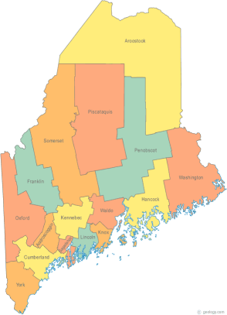 | Maine Continuum of Care (MCOC) Agenda  May 19, 2016 1:00 pm to 3:00 pm  Meeting at FIVE locations via Tandberg Conferencing System.  - Turner Memorial Library, 39 2nd St., Presque Isle  - Farmington Public Library, 117 Academy Street, Farmington  - MaineHousing, 353 Water Street, Augusta  - Lewiston Public Library, 200 Lisbon Street, Lewiston  - Portland Public Library, 5 Monument Square, Portland  THE CALL-IN ONLY NUMBER FOR THIS MEETING IS 866-6433. If you are at a Tandberg Location, use the system audio, not the call in.
---Agenda Items---
- Member Introductions |  | All
- Review & Approval of minutes |  | All | Need to Vote
- Big Thinking Topic – System Priorities |  | All
- Steering Committee Update |  | All
- State and Federal Legislation |  | Cullen
- Statewide Homeless Council |  | Wes or Cullen
- Regional Homeless Council Updates |  | All
- Long Term Stayers Update |  | All
- Vets@Home TA Update |  | Phil Allen
- CoC Board Update |  | All
- HUD CoC/PHA Forum – Update |  | All
- CoC NOFA Update |  | All
- Bread of Life Ministries – Crosby St. Change of Use Request |  | All | Need to Vote
- Project & Monitoring Tools and Processes – Review Changes |  | All | Need to Vote
- Maine Homeless Veteran Action Committee to become a joint standing committee of the Maine CoC |  | All | Need to Vote
- PIT/HIC Submission Update |  | All
- Any Other Business |  | All
Next Meetings: June 16th, 1pm to 3pm
Please read all posted materials prior to attending the meetings in order to be prepared to participate in the discussion.
Materials will be posted at www.mainehomelessplanning.org
Contact ppaladino@mainehousing.org for more information.

