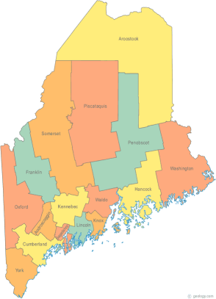 | Maine Continuum of Care (MCOC) Agenda  April 21, 2016 1:00 pm to 3:00 pm  Meeting at FIVE locations via Tandberg Conferencing System.  - Turner Memorial Library, 39 2nd St., Presque Isle  - Farmington Public Library, 117 Academy Street, Farmington  - MaineHousing, 353 Water Street, Augusta  - Lewiston Public Library, 200 Lisbon Street, Lewiston  - Portland Public Library, 5 Monument Square, Portland –  THE CALL-IN ONLY NUMBER FOR THIS MEETING IS 866-6433. If you are at a Tandberg Location, use the system audio, not the call in.
---Agenda Items---

- Member Introductions |  | All
- Review & Approval of minutes |  |  | Need to Vote
- Big Thinking Topic – MaineCare program changes and their anticipated effects. |  | All
- Steering Committee Update |  | All
- State and Federal Legislation |  | Cullen
- Statewide Homeless Council |  | Wes or Cullen
- Regional Homeless Council Updates |  | All
- Long Term Stayers Update |  | All
- Vets@Home TA Update |  | Phil Allen
- CoC Board Update |  | All
- HUD CoC/PHA Forum on May 4 |  | All
- PIT/HIC Submission Review |  | All | Need to Vote
- Any Other Business |  | All
Next Meeting: May 10th, 1:00 pm to 3:00 pm
Please read all posted materials prior to attending the meetings in order to be prepared to participate in the discussion.
Materials will be posted at www.mainehomelessplanning.org
Contact ppaladino@mainehousing.org for more information.

