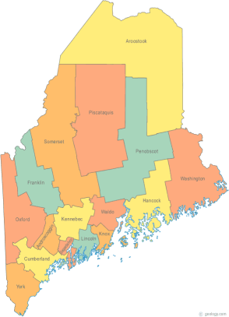
Maine Continuum of Care
Project Timeline

On Tuesday, September 16, 2004 HUD released the Notice of Funding Availability (NOFA) for the Continuum of Care Program Competition.

NOFA TIMELINE
FOR THE PROJECT COMMITTEE
DRAFT
9-19-14

Fri. Sept. 19, 2014 Project Committee Meeting 9a-12n
At MaineHousing

Fri. Sept. 19, 2014 Post Due Dates for Project Applications

Fri. Sept. 26, 2014 Response from Applicants who intend to
Apply.

Mon. Sept. 29, 2014 Steering Committee 10:00 am-12:00 pm

Fri. Oct. 3, 2014 Email check in to see who is coming in
(Heather L. to inform committee of who is
Applying for renewal or reallocation &
Bonus & New Project)
Fri. Oct 3, 2014 New Renewal Projects to submit
monitoring information to chairs

Mon. Oct. 6, 2014 Steering Committee 10:00 am-12:00 pm

Fri. Oct. 10, 2014 Project Committee Meeting to monitor
First time renewal projects and chairs to
Assign projects to members for compliance review.

Fri. Oct 10, 2014 E-SNAPS NEW PROJECTS and FIRST
TIME RENEWALS APPLICATIONS
(former Exhibit 2) DEADLINE TO
COMPLETE by 5:00 pm.

Mon. Oct 13, 2014 Holiday

Wed. Oct. 15, 2014 E-SNAPS RENEWAL PROJECT
APPLICATION (former Exhibit 2)
DEADLINE TO COMPLETE & submit in
e-snaps by 3:00 pm.

Thu. Oct. 16, 2014 8:00 am-1:00 pm Review & rank
All new projects & first time renewal
Applications

Fri. Oct.17, 2014 Notify Projects whether their application
will be included in the e-snaps submission

Mon. Oct. 20, 2014 Steering Committee 10:00 am-12:00 pm

Thu. Oct.23, 2014 Program Compliance Review by Project
Committee (location TBD) 9:00am-3:00 pm
(Hosted by OHI in Bangor)

Mon. Oct. 27, 2014 Steering Committee 10:00 am-12:00 pm

Tue. Oct. 28, 2014 MaineHousing submits NOFA application
in e-snaps

Thu. Oct. 30, 2014 HUD FINAL due date for NOFA Application

