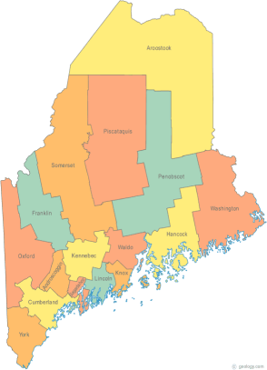 | MCOC Policy Committee  Minutes  Friday, July 15, 2014 4:00PM  Community Housing of Maine  309 Cumberland Ave., Suite 203  Portland, ME 04101  Call-in number 1-605-475-4350  Access Code: 810236# | All Committee Agendas and Minutes will be sent to MCOC Chairs by the 10th of each month for inclusion in materials sent to all members prior to each monthly MCOC meeting.
-Agenda Items-

- Welcome/Introductions/Attendance  Attendance: Cullen Ryan, Vickey Rand, Ginny Dill, Heather Rhoda, and Awa Conteh. Unable to attend: Chet Barnes and Donna Kelley | Group

- State and Federal Legislation Updates and Action Items  Please refer to the previously forwarded report. The highlights were reviewed. | Group

- Other Business
- The National Alliance to End Homelessness (NAEH) Annual Conference is two weeks away. A group or around 11 people from Maine will be attending and meeting with the Delegation.

- Next Meeting (confirm time and location)/Adjournment
- Unless otherwise decided meetings will occur on the third Tuesday of every other month at 4:00 PM.
- The next meeting is scheduled for Tuesday, September 16th at 4:00 PM.

