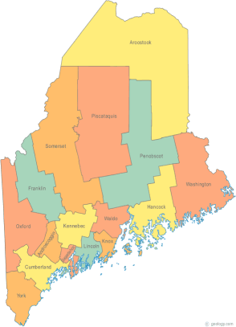 | Maine Continuum of Care (MCOC) Agenda  June 19, 2014 1:00 pm to 3:00 pm  Meeting at several locations via Tandberg Conferencing System.  - Turner Memorial Library, 39 2nd St., Presque Isle (awaiting confirmation)  - No location available in Washington County this time.  - Bangor Public Library, 145 Harlow Street, Bangor  - Farmington Public Library, 117Academy Street (awaiting confirmation)  - Maine State Library, 230 State Street, Augusta  - Lewiston Public Library, 200 Lisbon Street, Lewiston  - Portland Public Library, 5 Monument Square, Portland  For those not able to access a Tandberg Library site, there will be a conference line available. Call 1-866-316-1519 and enter code 9284295#
---Agenda Items---
- Member Introductions |  | All
- Review & Approval of minutes |  | All | Need to Vote
- Steering Committee |  | Chairs
- Project Committee |  | All
- Scoring Committee |  | Chairs
- Resource Committee  COC 101 |  | Chairs
- Data Committee |  | Chairs
- Policy Committee |  | Chairs
- DRAFT TA Request |  | Heather | Need to Review & Vote
- Planning Grant Update |  | Cindy / Steering Committee
- Long-Term Stayer Initiative Update |  | SHC representatives
- Statewide Homeless Council |  | Cullen or Wes
- HMIS Training announcement |  | Data Group Chairs
- Announcements & Updates |  | All
- Next Meeting
- August 21, 2014
Please bring all e-mailed material to the meeting. Contact stibbitts@mainehousing.org for more information.

