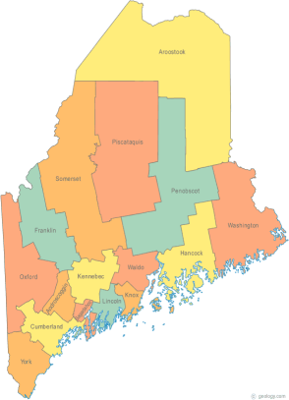 | Maine Continuum of Care (MCOC) Agenda  August 15, 2013 1:00 pm to 3:00 pm  MCOC will be meeting simultaneously at FIVE different  locations via the Tandberg Teleconferencing System.  - Turner Memorial Library, 39 2nd Street, Presque Isle  - Bangor Public Library, 145 Harlow Street, Bangor  - Farmington Public Library, 117Academy Street, Farmington  - Maine State Library, 230 State Street, Augusta  - Portland Public Library, 5 Monument Square, Portland
---Agenda Items---
- Member Introductions |  | All
- Review/Approval of minutes |  | All
- Old Business: Updates on work in progress
-Projects under development
Other Project information
- MMCA – final property sold (Elm Street, Bath)
- New Business  - Planning Project Awarded (Effective Jan. 2014)  - TIER 2 Projects Awarded  - Setting MCOC Priorities  - Homeless Planning Website |  | All  Cindy/Clif
- Steering Committee  - SNAPS Weekly Focus |  | Heather/Paula
- Project Committee  - Monitoring Tool  - Need Priorities to work on Scoring Template |  | Tiffany/Wes/  Donna
- Data Committee

- Resource Committee
- MCOC 101
- Policy Committee
- Statewide Homeless Council

- Other Business:

- Next meeting

September 19, 2013—Library Conferencing

Please bring all e-mailed material to the meeting. Contact stibbitts@mainehousing.org for more information.

